**Can You Catch a Phish?**

Read the following pages about the features of a fraud email. In the second part, analyze eight examples of emails and determine whether or not each is legitimate. You will explain your reasons in writing.

Phishing is the practice of sending a fraudulent email in hopes of stealing data or money. The email is the “bait.” You are the fish. Don’t take the bait.

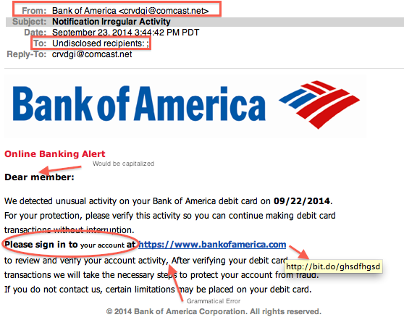If you are a really big fish, such as a company executive, celebrity, wealthy individual, or employee with valuable trade secrets, then you might be the victim of “Whale Phishing.” Phishing for Whales can be more lucrative. Fraudsters might be willing to do some research and craft a very specific attack just for you.

Here are some general principles for catching the phisher:

* **Don’t trust the display name** – A display name doesn’t really mean anything to the email delivery system. It can be set to whatever the sender wants. Check the header to see the email address that you are receiving it from.
* 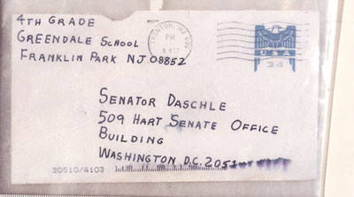**Don’t trust the return address** – Your best friend sent you a strange message. It appears that her real email address is listed in the From: field. That is no guarantee that the message came from her. It doesn’t even indicate that her email account was hacked. Spoofing a return address is as easy as writing an incorrect return-address on a normal postal letter or package. The return address was probably picked up in some public exchange of information.
* **Never click a link** – A good practice is to never click a URL link in an email. You can hover over the link and a URL will show on the bottom of the browser or next to the URL as shown in the picture above. The display name for the URL is bankofamerica.com but the actual URL text is something else. Instead of clicking the link, open a new browser window and type in the company website address directly or search Google for the company rather than clicking on the link.
* 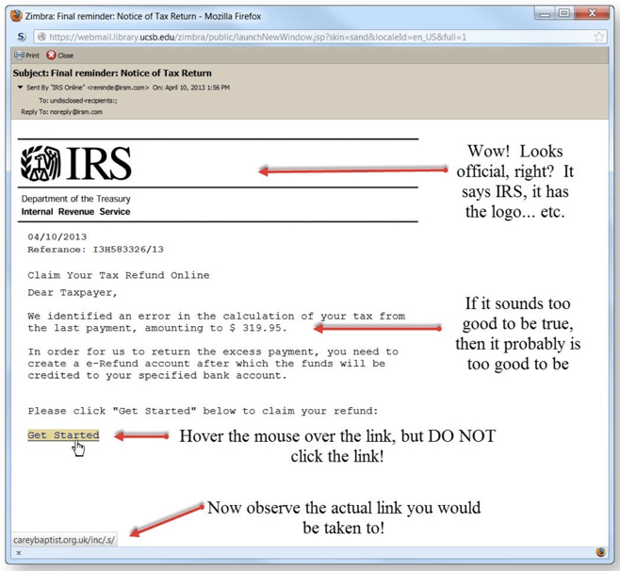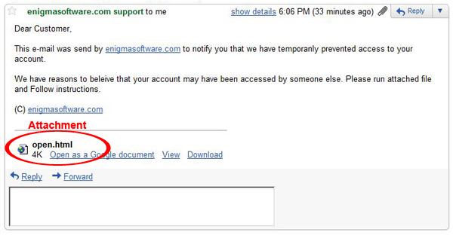**Don’t click, download or open attachments** – Attachments can and most certainly do contain malware. A simple Word document, PDF, and especially a computer program can damage computer files, steal passwords, and spy on your every move. If you feel that you must respond to a message, the best way is to open a new tab in your browser and navigate manually to the URL for the company. Lookup the contact information from their website. You may call, email, or login to the site and confirm that the message is real. Do not reply directly to a suspicious email. Do not click any links in the email. Do not call any phone numbers in the email.
* **Check for spelling mistakes** – Grammatical and spelling errors are a sure sign of a nonofficial email. People who are not native English speakers or writers are going to make odd grammatical mistakes. A close spelling mistake is also a good way to fool people. Should you reply to [customerservice@barnesandnobel.com](mailto:customerservice@barnesandnobel.com) or to [customerservice@barnesandnoble.com](mailto:customerservice@barnesandnoble.com) ? A closely spelled domain name can fool most of us. Who owns the URL for www.walmart-customer-service.com? It probably isn’t WalMart.
* **General Greetings are Suspicious** – Who is the email directed to? A “valued customer” is not what your bank usually calls you. A legitimate email will often contain a personal greeting using your first and last name.
* **Don’t give up personal information** – Banks and other professional companies will never, ever ask for personal information over email.
* **Beware of urgent or threatening language in the subject line** – Urgency can push people to worry and give up information easier and faster than ever. The message 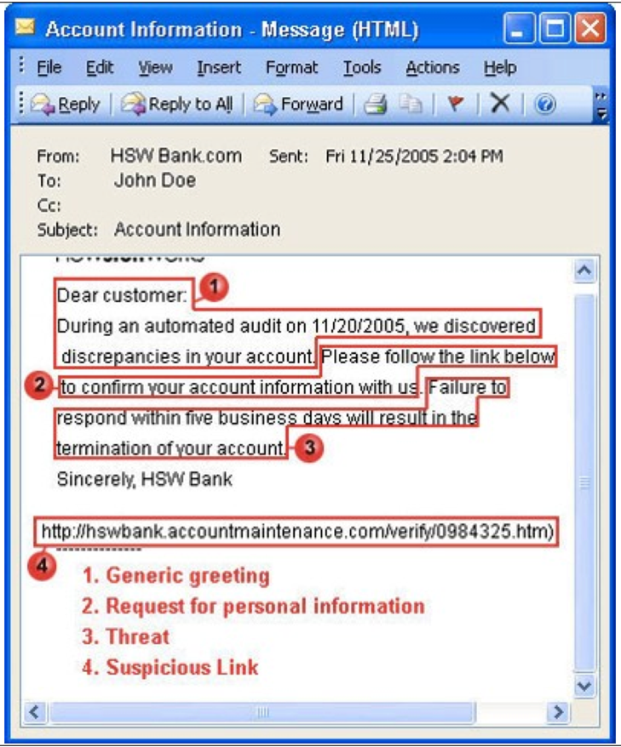might threaten to suspend your account, alert you to an unauthorized login attempt, or inform you of unexpected purchases. The email might inform you that it discovered a virus on your computer. You might be arrested for not replying. If you would like to confirm that you are indeed in trouble with the IRS, ICE, your bank, or the FBI, then contact them directly with a separate email or a phone call.
* **Review the signature** – Lack of details about the signer is an indicator of Phishing. Companies will not only have a name, but also an address, contact phone number, email, web address, etc.
* **Don’t believe everything you see** – Just because the email has professional images, a company logo, or valid email, it does not mean that the email is legitimate.

**Companies can design legitimate emails poorly**

Some emails from companies look exactly like phishing attempts. Consider this message from Hilton to their HHonors members <https://twitter.com/HiltonHonors/status/757655290959499264>

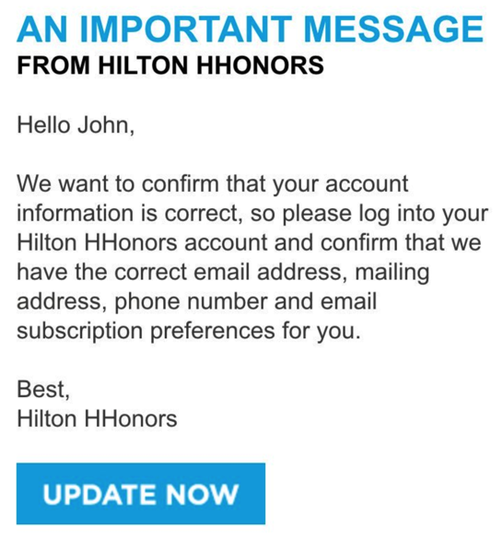The message was so badly designed that Hilton’s tech support team thought that the message was a phishing attempt. They told their customers not to open it. One of the customers, Mike, read the email header. Noticing that the information looks legitimate he says, “Either someone sent if from Hilton, or you’ve been hacked badly. Which one is it?” It turns out that the message was actually sent from Hilton, but designed very poorly.

